Task : 1
Ubuntu Server Installation on Oracle VM VirtualBox

Objective: Create a dedicated Virtual Machine (VM) using Oracle VM VirtualBox, mount the Ubuntu Server LTS ISO image, execute the automated/interactive installer, configure system credentials and network settings, and verify successful system deployment at the CLI login prompt.

Parameter | Configuration Specification | Description
Virtualization Software | Oracle VM VirtualBox (v7.x) | Host Hypervisor Environment
Guest Operating System | Ubuntu Server LTS (64-bit) | Target Linux Server Distribution
Allocated RAM (Memory) | 2048 MB (2 GB) | Dedicated RAM for Virtual Machine
Processor Cores (CPU) | 2 Virtual CPUs | Assigned CPU Processing Power
Virtual Hard Disk (VDI) | 25 GB (Dynamically Allocated) | Storage Virtual Disk Partition
Network Adapter | Bridged Adapter / NAT | Network Connectivity Interface

2. Step-by-Step Installation Procedure:
1.VM Setup in VirtualBox:Step 1: Create a New Virtual Machine.
- Open Oracle VM VirtualBox and click New.

- Enter VM details: Name: Ubuntu-Server-VM, ISO Image: Select downloaded Ubuntu Server ISO.

- Check Skip Unattended Installation for manual control.
2.Memory & Disk Sizing:Step 2: Allocate Hardware Resources.
- Set Base Memory to 2048 MB and Processors to 2 CPUs.

- Select Create a virtual hard disk now and set size to 25 GB (VDI format). Click Finish.
3.Interactive Setup Wizard:Step 3: Boot & Run Ubuntu Installer.
- Start the VM. Upon boot, select Try or Install Ubuntu Server.

- Choose your preferred language (e.g., English) and keyboard layout configuration.
4.Network & Disk Partitioning:Step 4: Configure Network & Storage.
- Network Connections: Keep default DHCP interface configuration (or configure static IP).

- Storage configuration: Select Use an entire disk and keep default LVM setup.
5.User Credentials & OpenSSH:Step 5: Profile & SSH Setup.
- Enter your profile details:

  - Your name: Admin User

  - Your server's name: ubuntu-server

  - Username: ubuntuuser

  - Password: StrongPassword123

- Check Install OpenSSH server to allow remote terminal management via SSH.
3. Post-Installation Verification & CLI Login:
Once installation finishes and the system reboots, the server loads the Linux kernel and presents the system login prompt:

Ubuntu 24.04.1 LTS ubuntu-server tty1

ubuntu-server login: ubuntuuser
Password:
Last login: Tue Oct 13 18:30:15 UTC 2026 on tty1
ubuntuuser@ubuntu-server:~$

Quick CLI System Verification Command:

ubuntuuser@ubuntu-server:~$ hostnamectl
Static hostname: ubuntu-server
Icon name: computer-vm
Chassis: vm
Machine ID: c1a2b3c4d5e67890
Boot ID: 9876543210fedcba
Virtualization: oracle
Operating System: Ubuntu 24.04.1 LTS
Kernel: Linux 6.8.0-31-generic
Architecture: x86-64

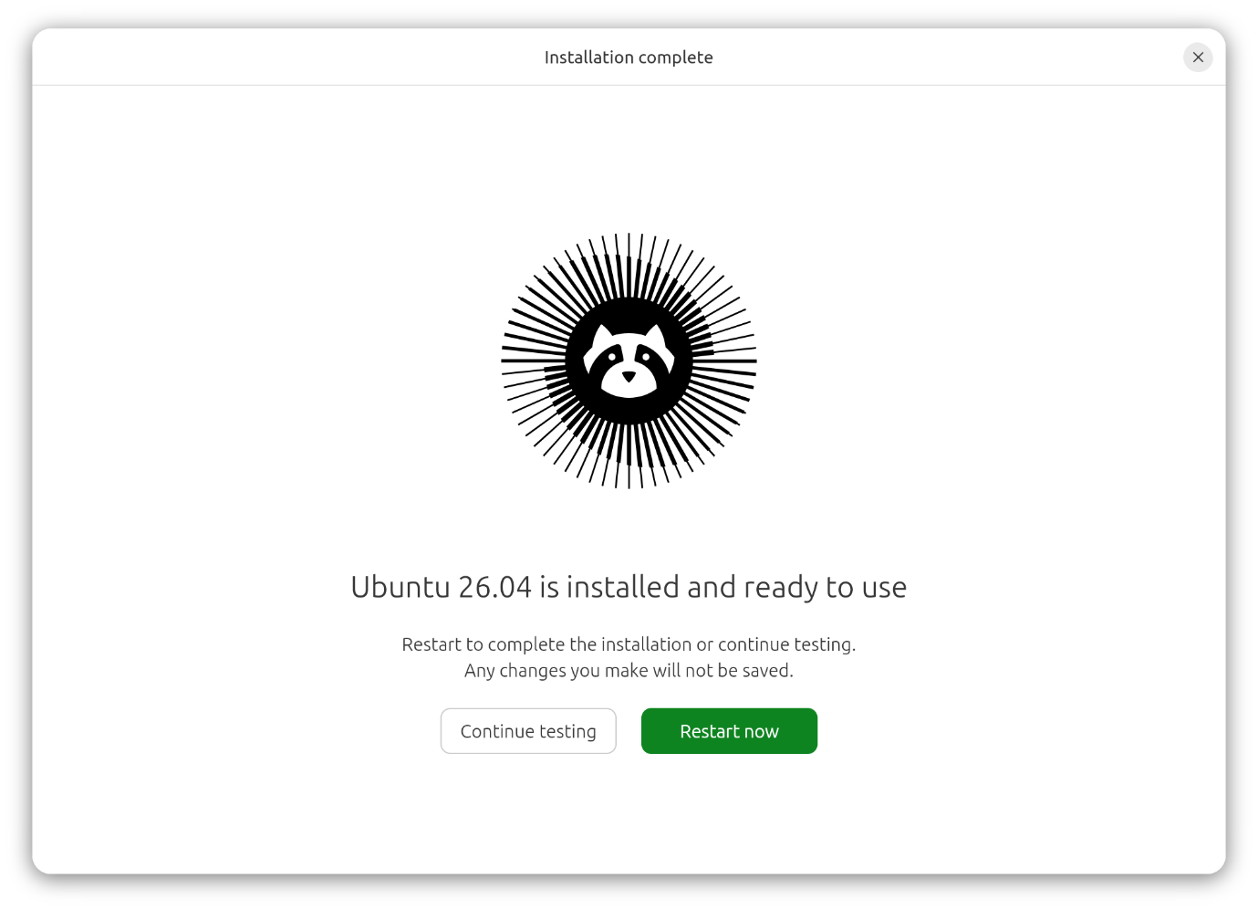

Task : 2
Linux Terminal Directory & File System Creation (MyMusic Workspace)

Objective: Open the Linux terminal interface on Ubuntu Server, execute basic file system management commands to create a dedicated directory named MyMusic, and initialize three empty text files (playlist.txt, songs.txt, and artists.txt) within it for local file organization.
1. Step-by-Step Execution Procedure:
1.Access Ubuntu CLI Environment:Step 1: Open Terminal Interface.
- Log into your Ubuntu Server VM using your username and password.

- Ensure you are in your user's home directory (~).
2.Run mkdir Command:Step 2: Create the Target Directory.
- Create a new directory named MyMusic by executing the following command in the terminal:
3.Run touch Command:Step 3: Create Empty Files Inside Directory.
- Initialize the three required empty files inside the MyMusic directory in a single command:
4.Run ls Verification Command:Step 4: Verify Directory Contents.
- List the contents of the directory to confirm successful creation:
2. Terminal Command Execution & Output Logs:

ubuntuuser@ubuntu-server:~$ mkdir MyMusic

ubuntuuser@ubuntu-server:~$ touch MyMusic/playlist.txt MyMusic/songs.txt MyMusic/artists.txt

ubuntuuser@ubuntu-server:~$ ls -la MyMusic/
total 8
drwxr-xr-x 2 ubuntuuser ubuntuuser 4096 Oct 14 11:20 .
drwxr-xr-x 4 ubuntuuser ubuntuuser 4096 Oct 14 11:20 ..
-rw-r--r-- 1 ubuntuuser ubuntuuser 0 Oct 14 11:20 artists.txt
-rw-r--r-- 1 ubuntuuser ubuntuuser 0 Oct 14 11:20 playlist.txt
-rw-r--r-- 1 ubuntuuser ubuntuuser 0 Oct 14 11:20 songs.txt

3. File System Creation Summary Table:

Action / Operation | Command Executed | Target File / Directory Name | Resulting Status
Directory Creation | mkdir | MyMusic | Created successfully (Permissions: drwxr-xr-x)
File Initialization | touch | playlist.txt, songs.txt, artists.txt | Created with 0 bytes size
Directory Verification | ls -la | MyMusic/ | All 3 files listed successfully

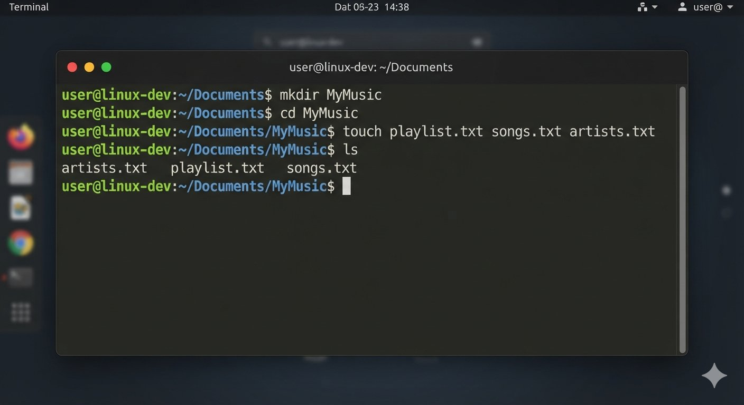

Task : 3
Comparative Technical Analysis: Linux File System Hierarchy vs. Windows

Objective: Conduct a structured technical comparison between the Linux Unified Root Directory structure (/) and the Windows Drive-Letter Partitioning system (C:\), evaluating path syntax, root architecture, system organization, and permission models.

# | Comparison Parameter | Linux File System Structure (Ubuntu/Unix) | Windows File System Structure (NTFS)
1 | Root Directory & Structure | Single Unified Hierarchical Tree starting from the root directory (/). All drives and mounts branch off from this single tree. | Drive-Letter Partition Model starting with primary boot drive (C:\), followed by (D:\, E:\), maintaining separate trees per partition.
2 | Path Separator Syntax | Uses forward slashes (/) for directory paths (e.g., /home/ubuntuuser/MyMusic). | Uses backward slashes (\) for directory paths (e.g., C:\Users\Admin\Documents).
3 | System & Configuration Files | Centralized configuration in text files located within specific directories (e.g., /etc/, /var/log/). | Configuration stored in a centralized hierarchical database known as the Windows Registry.
4 | Case Sensitivity | Strictly Case-Sensitive. MyMusic and mymusic are treated as two completely distinct directories. | Case-Insensitive by default. MyMusic and mymusic reference the exact same folder location.
5 | User Home Directory | Located under /home/username (e.g., /home/ubuntuuser). | Located under C:\Users\username (e.g., C:\Users\Admin).

Summary of Core Differences:
- Linux enforces a modular, case-sensitive single-root directory scheme where everything—including hardware devices (/dev) and mounts—is treated as a file.
- Windows relies on physical or logical drive-letter segmentation with case-insensitive pathing, optimized for desktop and GUI user experiences.

Task : 4
Comparative Analysis: Ubuntu Server vs. Windows PC File System Structure

Objective: Compare the architectural differences between the Linux (Ubuntu Server) unified directory hierarchy and the Windows (NTFS) file system structure, highlighting three key operational differences with specific reference to core system and user directories (e.g., /home, /etc, C:\Users).

1. Key Structural Differences (Ubuntu Server vs. Windows):
Difference 1: User Home Directory Organization (/home vs. C:\Users)
- Ubuntu Server: All standard user accounts and their personal files are housed inside the centralized /home directory (e.g., /home/ubuntuuser), which acts as the default container for user-specific data and workspace configurations.
- Windows PC: User profiles, documents, desktop items, and application data are structured under the C:\Users\ directory (e.g., C:\Users\Admin), separated by individual user account names.
Difference 2: System Configuration Management (/etc vs. Windows Registry / C:\Windows)
- Ubuntu Server: System-wide configurations and service settings are stored as plain-text files inside the /etc directory (e.g., /etc/netplan/, /etc/ssh/), allowing easy editing via terminal text editors like nano or vim.
- Windows PC: Configuration settings are largely centralized within a proprietary hierarchical database called the Windows Registry (regedit), supplemented by system files stored in C:\Windows\System32 and C:\ProgramData.
Difference 3: Root Architecture & Drive Mounts (/ Unified Root vs. Drive Letters C:\, D:\)
- Ubuntu Server: Operates on a single unified hierarchical tree starting from the root directory (/). External drives, secondary partitions, and network shares are mounted into this single tree (e.g., /mnt/backup, /media/usb).
- Windows PC: Relies on drive-letter partitioning where each physical or logical partition operates as an independent root drive tree (e.g., C:\ for OS, D:\ for data, E:\ for external media).
2. Summary Comparison Table:

Feature / Parameter | Ubuntu Server File System | Windows PC File System (NTFS)
Root Reference | Single Root Directory (/) | Drive Letter Roots (C:\, D:\)
User Directory | /home/ubuntuuser | C:\Users\Admin
Configuration Storage | Plain-text files in /etc/ | Windows Registry & C:\Windows
Path Separator | Forward Slash (/) | Backward Slash (\)
Case Sensitivity | Case-Sensitive (MyMusic $≠$ mymusic) | Case-Insensitive (MyMusic = mymusic)

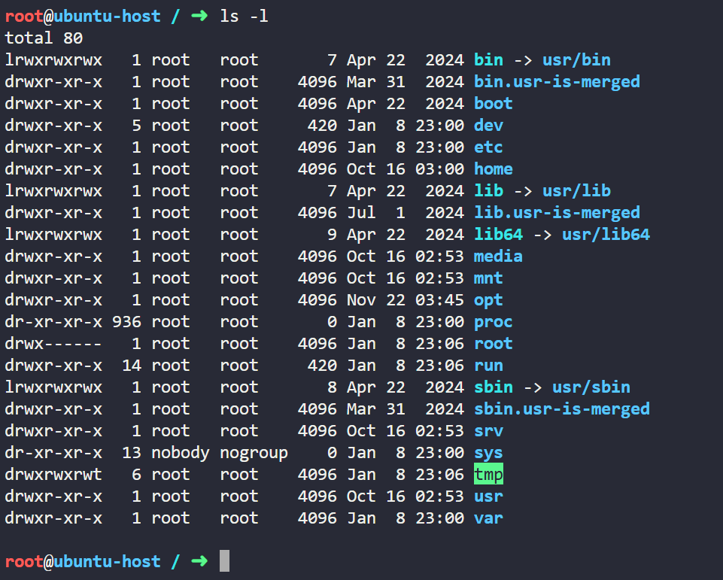

Task : 5
Exploring Linux Manual Pages via man Command (ls Utility)

Objective: Utilize the Linux built-in manual documentation utility (man) to research the functionality of the ls (list directory contents) command, analyze its syntax and flags, and document a newly learned command-line option (-h for human-readable file sizes).

1. Step-by-Step Execution Procedure:
1.Run man ls Command:Step 1: Open Command Manual.
- Open your Ubuntu terminal and execute the manual command for ls:
2.Navigate Manual Pages:Step 2: Read Documentation & Search Options.
- Scroll through the manual description to understand that ls lists information about files (the current directory by default).

- Look up various command flags and options (e.g., -l, -a, -h). Press q to exit the manual viewer.
3.Execute ls -lh Command:Step 3: Test the Newly Learned Option.
- Run the listing command combined with the human-readable size flag inside your working directory:
2. Terminal Command Execution & Manual Output Logs:

ubuntuuser@ubuntu-server:~$ man ls

(Manual page viewer opens displaying description and options)

LS(1) User Commands LS(1)

NAME
ls - list directory contents

SYNOPSIS
ls [OPTION]... [FILE]...

DESCRIPTION
List information about the FILEs (the current directory by default).
Sort entries alphabetically if none of -cftuvSUX nor --sort is specified.
...

Testing the Newly Learned Option (-h):

ubuntuuser@ubuntu-server:~/MyMusic$ ls -lh
total 8.0K
-rw-r--r-- 1 ubuntuuser ubuntuuser 0 Oct 14 11:20 artists.txt
-rw-r--r-- 1 ubuntuuser ubuntuuser 0 Oct 14 11:20 playlist.txt
-rw-r--r-- 1 ubuntuuser ubuntuuser 0 Oct 14 11:20 songs.txt

3. Learned ls Option Breakdown:
- Option Learned: -h (or --human-readable)
- Description: When combined with the long listing format (-l), the -h flag prints file sizes in a human-readable format (e.g., 1K, 234M, 2G) rather than raw byte counts, making it much easier to read storage sizes at a glance.
4. Summary Reference Table:

Command & Flag | Description / Purpose | Output Format Example
man ls | Accesses built-in system manual pages for ls | Displays full documentation and flags
ls -l | Uses long listing format with permissions and sizes | File sizes displayed in raw bytes
ls -lh | Long listing with Human-Readable sizes | File sizes displayed as 4.0K, 15M, etc.

